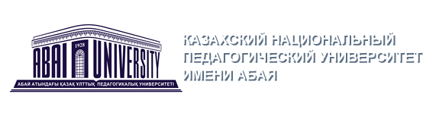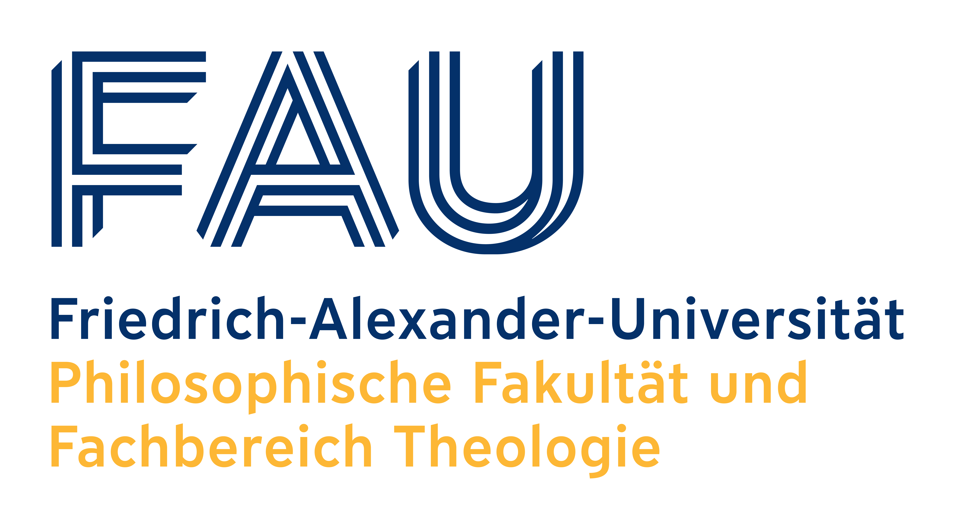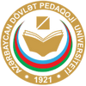

Dual Models of Training of Future Pedagogical Professionals in the International Educational Space: Problems, Solutions, Prospects

Conference Date: 11-12th October, 2022
Article and application Submission Date: 20th September 2022

Venue of the conference: Abai Kazakh National Pedagogical University,
Dostyk Avenue 13, Conference Hall

The conference is a part of the project “Pedagogical Professionalism and Internationalization – Dialogue with the Post-Soviet Islamic Education Space” by the Research and Teaching Unit Diversity Education and International Education Research at Friedrich-Alexander-University Erlangen-Nürnberg (FAU) in cooperation with Abai Kazakh National Pedagogical University (KazNPU) and Azerbaijan State Pedagogical University (ASPU). The German Academic Exchange Service (DAAD) funds the project from the funds of Federal Foreign Office (AA) as part of the program “Higher Education Dialogue with the Muslim World”. The conference is organized and hosted by Abai Kazakh National Pedagogical University (KazNPU).

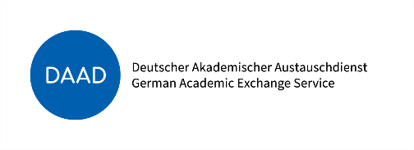

Dear colleagues!

We invite you to participate in the international scientific conference “Dual Models of Training of Future Pedagogical Professionals in the International Educational Space: Problems, Solutions, and Prospects”. The conference will be held on October 11-12, 2022 at Abai KazNPU, Almaty.

The conference seeks to promote the scientific dialogue about the connection of theory and practice in the training of pedagogical professionals in (international) education and focuses on the potential of the dual models of training in the post-industrial digital era. In particular, the conference presentations discuss the modification of bachelor's and master's degree programs that implement the dual education paradigm for future specialists in (international) education.
The aim of the conference is to exchange international research and experience of universities in Kazakhstan, Germany, Azerbaijan and other countries, and in particular
- to identify innovative areas of educational research;
- search for ways to improve the professional education by expanding the professional networks of the global educational community;
- discuss organizational and pedagogical principles that determine the influence of the macro-environment of professional education on the dualization of training of pedagogical professionals.

Main directions of the conference:

1. Social and pedagogical practice of implementing models of dual training in vocational and higher education in Kazakhstan, Germany and Azerbaijan and their reference to international educational spaces.
2. Pedagogical problems and psychological support of dual training of pedagogical professionals, in particular in international education
3. Innovative models of dual training of pedagogical professionals and new technologies: (personalized, digital, trainings with elements of artificial intelligence, professional training in networks).

The Organizing Committee reserves the right to select articles for publication. Only articles related to the topic of the conference will be accepted.
Conference format (offline and online):
- plenary session
- work of the sections in directions
Papers can be submitted by one or no more than three co-authors and presented by the main author. As a speaker, you will have 20 minutes allocated to your paper, including 10 minutes for presentation and 10 minutes for discussion

Based on the results of the conference, a certificate of participation will be issued, and it is planned to publish a collection of scientific papers of the conference, which will receive the international ISBN.

The working language of the conference is English.
Applications for participation in the conference and for articles will be accepted until September 20, 2022 at the e-mail address: dual-kaznpu-conf@mail.ru .The application form and the requirements for the design of the article are attached.
Contact person: Madina Moldagali, tel: +7 775 188 8479

